**Exercise 5: Online Bookstore - Customizing Response Status and Headers**

Business Scenario:

Customize the HTTP response status and headers for the book management endpoints.

**Key Points:**

1. **Customizing Response Status:**
   * **@ResponseStatus(HttpStatus.CREATED)**: This annotation is used in the addBook method. It sets the HTTP status code to 201 Created when a new book is successfully added. This status code indicates that the request was successful and a resource was created as a result.
2. **Adding Custom Headers:**
   * **ResponseEntity.noContent().header("Custom-Header", "Book deleted").build()**: In the deleteBook method, ResponseEntity is used to customize the HTTP response. The method noContent() sets the response status to 204 No Content, indicating the request was successful but there is no content to return. Additionally, a custom header "Custom-Header" is added to the response with the value "Book deleted". This allows for including additional information in the response metadata.

**Endpoints Overview:**

* **GET /books**: Retrieves a list of all books. Returns a default 200 OK status.
* **POST /books**: Adds a new book. Uses @ResponseStatus(HttpStatus.CREATED) to return 201 Created status.
* **PUT /books/{id}**: Updates an existing book. Returns the updated book with a default 200 OK status.
* **DELETE /books/{id}**: Deletes a book. Uses ResponseEntity to return a 204 No Content status with a custom header.
* **GET /books/{id}**: Retrieves a specific book by its ID. Returns a default 200 OK status.
* **GET /books/search**: Searches for books based on title and author. Returns a default 200 OK status.

**FLOWCHART :**

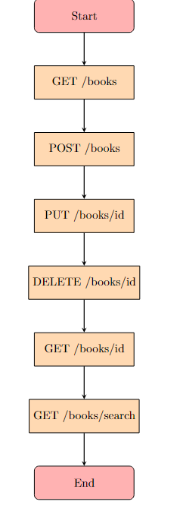

**Explanation:**

* **Start**: Represents the beginning of the process.
* **GET /books**: Endpoint to retrieve a list of all books.
* **POST /books**: Endpoint to add a new book. It sets the HTTP status to 201 Created.
* **PUT /books/{id}**: Endpoint to update an existing book.
* **DELETE /books/{id}**: Endpoint to delete a book and set a custom header for the response.
* **GET /books/{id}**: Endpoint to retrieve a specific book by its ID.
* **GET /books/search**: Endpoint to search for books by title and author.
* **End**: Represents the end of the process.

**CLASS DIAGRAM :**

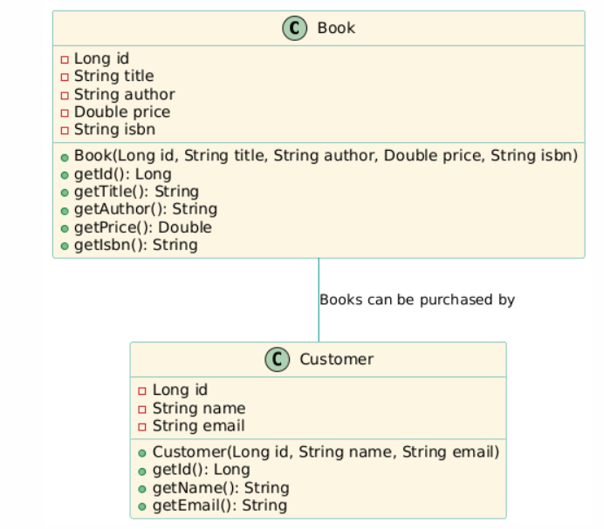

**Explanation:**

* **Book Class**: Represents a book with attributes such as id, title, author, price, and isbn. Includes a constructor and getter methods for these attributes.
* **Customer Class**: Represents a customer with attributes such as id, name, and email. Includes a constructor and getter methods for these attributes.
* **Relationship**: There is a directed association between Book and Customer, indicating that books can be purchased by customers.